What Really Drives the Rupee? A Data-Driven Intelligence System for Explaining and Predicting USD/INR Movements

1. Project overview
We propose to build a Rupee Intelligence System in R that explains which economic and financial factors move the USD/INR exchange rate, how strongly each one matters, and how the rupee might respond to a shock such as oil rising 10%.
Group members
# | Name | Roll number
1 | Ankit Singh | EMBAA25004
2 | Aswin G. | EMBAA25008
3 | Atul Kumar Singh | EMBAA25009
4 | Devanshu Priyam | EMBAA25014
5 | Gopalakrishnan S | EMBAA25017
6 | Murugan Perumal | EMBAA25020

2. Background and motivation
The rupee's value against the dollar affects import bills, export margins, foreign debt servicing, inflation and investment decisions across Indian business. Yet public discussion often reduces its movements to a single cause, most commonly "oil went up, so the rupee fell".
In reality several forces act together: crude oil prices and the trade deficit shape dollar demand; foreign portfolio flows shape dollar supply; interest-rate and inflation gaps between India and the US shift relative returns; and global dollar strength moves all emerging-market currencies. RBI research has itself modelled USD/INR alongside oil prices, domestic CPI, monetary policy and capital flows.
This project tests these explanations with data instead of assuming them. The managerial value is a decision-support tool: a treasury, import-heavy or export-oriented business can see which factors matter most and stress-test the rupee under plausible scenarios.

3. Objectives and research questions
The project has four objectives: explain past rupee movements, rank the drivers, flag high-pressure months, and simulate what-if scenarios.
# | Research question | Primary technique
RQ1 | Which factors move together with USD/INR? | Descriptive statistics, correlation matrix
RQ2 | Which factors have the strongest statistical relationship with USD/INR, holding others constant? | Multiple linear regression
RQ3 | Is oil really the villain, or is the rupee driven by a combination of domestic and global factors? | Nested model comparison (Models A, B, C)
RQ4 | Can we predict whether a month will be a high-pressure month for the rupee? | Logistic regression, decision tree, confusion matrix
RQ5 | What happened to the drivers during major rupee shocks (2013 taper tantrum, 2020 COVID, 2022 oil shock)? | Event-window analysis, t-test / ANOVA across periods
For RQ3, the three nested models are:
- Model A: crude oil only
- Model B: oil + inflation
- Model C: oil + inflation + interest-rate differential + FPI flows + trade balance + dollar index
They are compared on R², adjusted R², RMSE, MAE, coefficient significance and out-of-sample accuracy.

4. Data sources and variables
We will build one master monthly dataset from free official sources for January 2010 to December 2025, about 192 observations. No paid or ready-made (e.g. Kaggle) datasets will be used.
Variable | Role | Source | Series / note | Expected effect on USD/INR
USD/INR (monthly average) | Target | RBI DBIE; cross-check with FRED | FRED DEXINUS | —
Crude oil, Brent (USD/barrel) | Driver | World Bank Commodity Prices (Pink Sheet) | Monthly XLS | ↑ (higher import bill)
Broad US dollar index | Driver | FRED | DTWEXBGS (not ICE DXY) | ↑ (stronger global dollar)
India CPI inflation (YoY %) | Driver | RBI DBIE | Computed from CPI index | ↑
US CPI inflation (YoY %) | Driver | FRED | CPIAUCSL | ↓
India repo rate (%) | Driver | RBI DBIE | Policy rate | ↓
US Fed funds rate (%) | Driver | FRED | FEDFUNDS | ↑
FPI net flows (USD mn) | Driver | NSDL / RBI DBIE | Positive = inflow | ↓ (more dollar supply)
Trade balance (USD bn) | Driver | RBI DBIE | Exports − imports | ↑ when deficit widens
Forex reserves (USD bn) | Driver | RBI DBIE | Level and monthly change | ↓ (buffer against pressure)
Expected directions are hypotheses to be tested, not assumptions. Derived features will include the rate differential (India repo − Fed funds), the inflation differential, monthly returns for USD/INR, oil and the dollar index, and the change in reserves.
The final CSV will have one row per month with the columns: Month, USDINR, Crude_Oil, Broad_USD_Index, India_CPI, US_CPI, India_Repo_Rate, US_Fed_Rate, FPI_Net_Flow, Trade_Balance_USD, Forex_Reserves_USD.

5. Methodology
The analysis runs as a nine-step pipeline in R, moving from raw data to explanation, prediction and scenarios.
- Data collection and integration: download each series, align to monthly frequency, merge on Month into one master CSV.
- Data cleaning: handle missing values, unit conversions and base-year differences; document every transformation.
- Exploratory data analysis: trends, frequencies, mean, median, standard deviation and volatility of each series.
- Correlation analysis: correlation matrix and heatmap between USD/INR and each driver (RQ1).
- Stationarity and feature engineering: test for trends (e.g. ADF test); use returns, changes and differentials where levels are non-stationary.
- Regression modelling: multiple linear regression (RQ2) and nested Models A, B, C (RQ3).
- Model diagnostics: multicollinearity (VIF), heteroskedasticity, residual analysis, overall significance, adjusted R².
- Classification: label each month Stable, Moderate Pressure or High Pressure from the size of the rupee move; predict it with logistic regression and a decision tree, evaluated with a confusion matrix (RQ4).
- Prediction and scenario analysis: train on 2010-2022, test on 2023-2025; then feed shocked inputs into the fitted model for the stress simulator.
The core regression specification is:
USDINR_t = \beta_0 + \beta_1 Oil_t + \beta_2 InflDiff_t + \beta_3 RateDiff_t + \beta_4 FPI_t + \beta_5 TradeBal_t + \beta_6 USDIndex_t + \varepsilon_t
Each coefficient reads as: a one-unit change in the driver is associated with a β change in USD/INR, holding the other drivers constant. We will report these as statistical associations, not causal effects.
Planned R packages include tidyverse, lubridate, readxl, corrplot, car, lmtest, tseries, rpart, caret and shiny.

6. Deliverables
The headline deliverable is a Rupee Intelligence Dashboard with four screens, powered by one R model and anchored by the Rupee Stress Simulator.
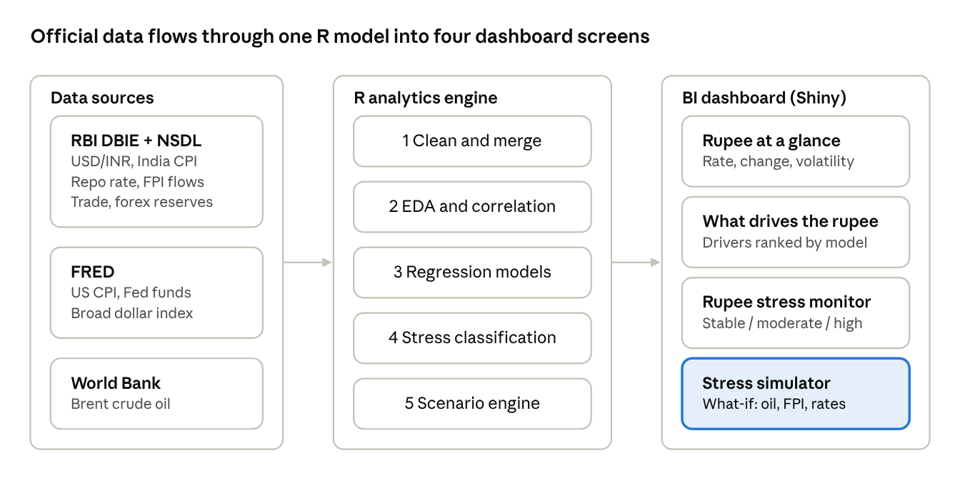
system architecture · 3 layers, 4 dashboard screens
The simulator is the signature feature; every screen draws on the same fitted model and dataset.
Deliverable | What it contains
Master dataset | Monthly CSV, Jan 2010 to Dec 2025, 11 columns, with a data dictionary and source log
R code | Reproducible scripts or R Markdown for cleaning, analysis, models and dashboard
Rupee Driver Scorecard | For each factor: direction, estimated coefficient, significance and business interpretation
Historical shock timeline | How the drivers behaved around 2008, 2013, 2020 and 2022 rupee episodes
Rupee Stress Simulator | User sets shocks (e.g. oil +15%, FPI −20%, Fed rate +0.50%); model returns a predicted USD/INR range, not a point forecast
Final report and presentation | Findings, model comparison, limitations and managerial implications (Sessions 19-20)

7. Expected outcomes and limitations
We expect to show whether oil alone explains rupee movements or whether a combination of domestic and global factors does, and to rank those factors by strength.
Expected outcomes
- A ranked, evidence-based list of USD/INR drivers with managerial interpretation
- A measured answer to "Is oil really the villain?" from the Model A-C comparison
- An early-warning classifier for high-pressure months
- A working what-if simulator for business decision support
Limitations
- Association, not causation: regression coefficients describe relationships, not proven causal effects.
- Endogeneity: the rupee and FPI flows influence each other; results will be interpreted with this in mind.
- Structural breaks: relationships may shift across periods (e.g. post-2013, post-COVID).
- Frequency mismatch: some series are weekly or quarterly and must be converted to monthly.
- Scenario ranges: simulator outputs are model-implied ranges with uncertainty, not forecasts.

